Qantum Cloudripper_Hardware_Design_Specification

Revision 1.0
08-16-2023

Table of Contents

1 Table of Contents 2
2 Table of Figures 3
3 Table of Tables 4
4 Revision History 5
5 Introduction 6
5.1 Purpose 6
5.2 Scope 6
5.3 Reference 6
5.4 Glossary 7
6 Functional Description 8
6.1 Feature List 8
6.2 General View 9
6.3 Function Diagram 11
6.4 Mechanical Dimension 11
7 Layout Placement 13
8 Detailed Design Description 14
8.1 Functional overview 14
8.1.1 I2C Tree 14
8.1.2 System Reset 15
8.2 System Monitoring and Control 15
8.2.1 Environmental sensors 15
8.3 Clock Design 15
8.3.1 Clock Requirements 15
8.4 On board Power Design 15
8.4.1 On board Power Requirement Analysis 16
8.4.2 Power Sequence Requirement Analysis 16
8.4.2.1 Timing Board Sequence Requirement 16
8.4.3 On Board Power Solution 16
8.4.3.1 Power Tree 16
8.5 JTAG 17
8.6 LEDs 17
8.6.1 Front Panel LEDs 17
9 Hardware Reliability Calculation 19
10 Manufacturing Process 20
11 Board Verification Concept 21
12 Design Analyze 22
13 Preliminary Calculation Cost on the Board 23
14 Environmenntal 24

Table of Figures

Figure 1 Timing Card Front Panel 9
Figure 2 Timing Card top view 9
Figure 3 Timing card overview 10
Figure 4 Timing Card Functional Block Diagram 11
Figure 5 Timing Card Placement 13
Figure 6 Timing Board power sequence requirement 16
Figure 7 Power Tree 17

Table of Tables

Table 1 Revision History 5
Table 2 Reference Table 6
Table 3 Glossary Table 7
Table 4 Timing card feature list 8
Table 5 Timing board I2C address 15
Table 6 Front panel LED definition 18

Revision History

Version | Date | Author | Description
0.1 | 10-04-2021 | Bhooshan Urva | Initial Draft
1.0 | 02-22-2022 | Bhooshan Urva | Updated with changes requested by customer for DVT build.  - PMOD connector  - FT4232 Quad high speed USB to multi-purpose UART/MPSSE  - Additional EEPROM for FPGA version number

Table 1 Revision History

Introduction

Purpose
The purpose of this document is to provide the board designer(s) with detailed operation and functional descriptions, as well as electrical and mechanical specifications for the PTP Timing Card.

Scope
This document will be used to specify the following design parameters:
- Basic Functional Description of the PTP Timing Card.
- Key components will be selected and detail board architecture will be included.
- External Interfaces will be defined
- Debug and Programming Interfaces will be defined
- Software Interfaces necessary to debug hardware
- Board Hardware Common Features will be defined.
- Power Requirements and Consumption.
- DFX strategy will be included.

Reference

Num | Document ID | Version | Description
1 | OCP Time card github repository | V1.0 | https://github.com/opencomputeproject/Time-Appliance-Project/tree/master/Time-Card
2 | R4006-M0019-01 |  | G:\Shared drives\FB_CLS_TimeCard\CLS2FB\GDS test plan\DVT\Plans\Timecard_hw_bring-up_and_function _test_[DVT]\Timecard_hw_bring-up_and_function _test_[DVT]_1525_22_Jun_2022\Timecard_hw_bring-up_and_function _test_[DVT]_1525_22_Jun_2022.pdf
3 | R4006-M0035-01 |  | R4006-M0035-01 Rev 1.0,Timing Card Environment and Reliability Test Plan
4 |  |  | R4006-Mxxx-xx_Timing_Card_SVT_Test_Plan_Rev1.0
5 | R4006-M0006-01 |  | R4006-M0006-01 Rev0.1Timing Model FB EVT DCDC Power Test Plan
6 | R4006-M0006-01 |  | R4006-M0006-01, V1.0, FB Timing Card EVT Signal Integrity Test Plan
7 | R4006-M0008-01 |  | R4006-M0008-01 Rev 0.1 FB_Timing card EMC Pre-scan Test Plan
8 | R4006-M0005 |  | R4006-M0005-01,Rev 0.1,CLS Time Card EVT Thermal Test Plan-20211025

Table 2 Reference Table

Glossary

Term / Abbreviation | Definition
GNSS | Global Navigation Satellite System
PTP | Precision Timing Protocol
NIC | Network Interface Card
RGB | Red, Green, Blue (tri-color)
I2C | Inter－Integrated Circuit
JTAG | Joint Test Action Group
PCIe | PCI Express
PLL | Phase Locked Loop
SPI | Serial Peripheral Interface
UART | Universal Asynchronous Receiver/Transmitter
USB | Universal Serial Bus
Table 3 Glossary Table

Functional Description
Timing board provides accurate time via GNSS while maintaining accuracy in case of GNSS failure via an atomic clock that provides highly stable holdover. The card is designed as a standard height full-size PCIe 3.0 x4 CEM form factor card that plugs into a server (through a custom riser card). SMA receptacle on the faceplate provides a connection for a GNSS antenna.

Feature List
The Timing card has the features shown in table below.

 | Description
1 | U-Blox RCB-F9T-0 GNSS receiver
2 | Microchip MAC-SA53 Atomic clock
3 | 1PPS SMA input
4 | 1PPS SMA output
5 | 10MHz SMA input
6 | 10MHz SMA output
7 | GNS Antenna SMA input
8 | PCIe Gen 3.0 x4 interface (plugs into a server through a custom riser card)
9 | Status indicator RGB LED for each SMA port
10 | Temperature sensors, 3x
11 | Pressure sensor
12 | Humidity sensor
13 | Vibration sensor
14 | PMOD connector (2x6, 0.1 inch pitch) for FPGA diagnostics
15 | FT4232H Quad USB to UART/MPSSE chip connected to faceplate USB-C port (for debug only)

Table 4 Timing card feature list

General View
Front panel
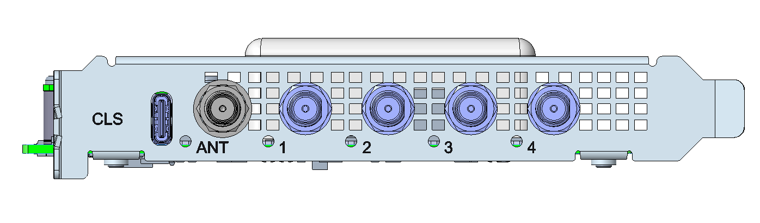
Figure 1 Timing Card Front Panel

Top View
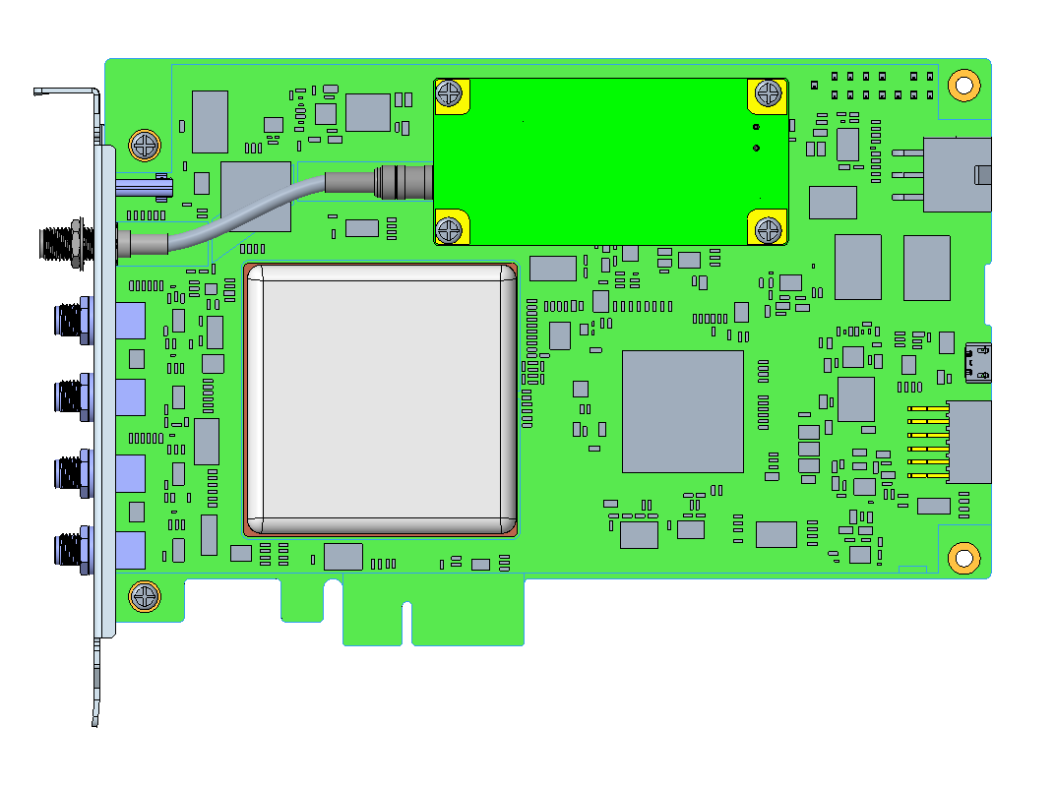
Figure 2 Timing Card top view
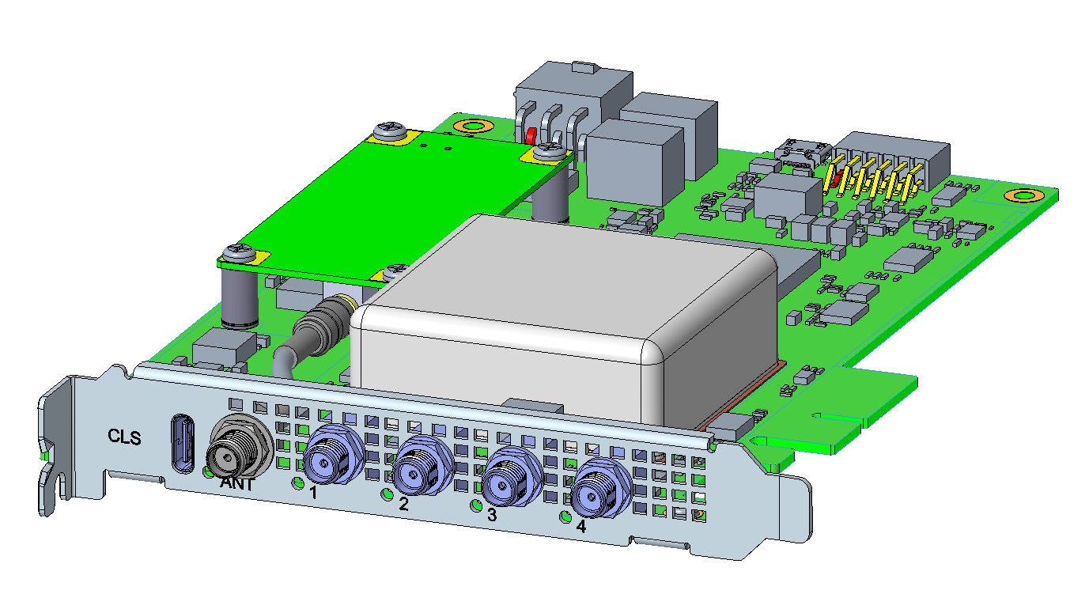

Figure 3 Timing card overview

Function Diagram
Ting card function block diagram can be seen in following figure.
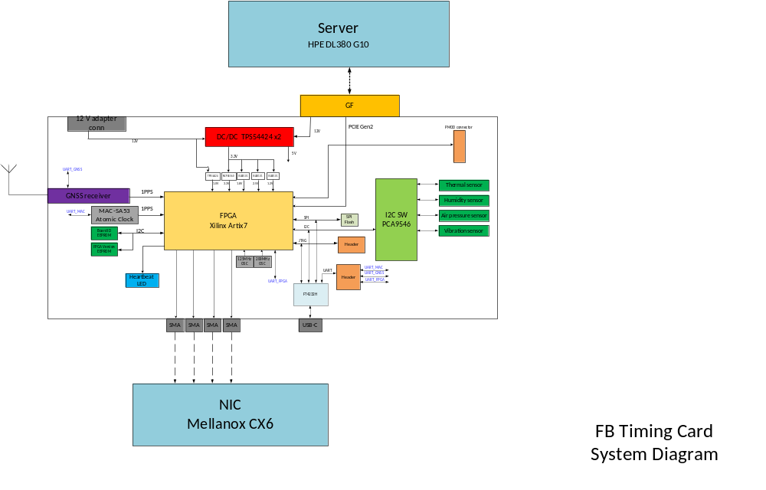
Figure 4 Timing Card Functional Block Diagram

The timing board has a GNSS receiver which receives GNSS clock. 1PPS outputs from both the GNS receiver and the on-board atomic clock (MAC-SA53) are sent to the FPGA.
The FPGA performs the following functions;
- PTP computations
- Send 1PPS and 10MHz clock to the Mellanox CX6 NIC
- Receive 1PPS and 10MHz clock from the Mellanox CX6 NIC
- Monitor the temperature sensors, pressure sensor, humidity sensor and the vibration sensors through I2C
- Collect board ID information from the Board ID EEprom
- Optionally drive the SMA RGB LEDs.
- Interface to the Server CPU through the PCIe 3.0 x4 interface.

Mechanical Dimension
The timing card is a PCIe CEM x4 half size form factor card with dimensions of 106.65mm width X 174mm length. The card is taller than the normal slot pitch due to the height of the miniature atomic card. A custom PCIe riser card is employed to accommodate the timing card in a server.

Layout Placement
The Layout placement drawing can be seen in the following figure.
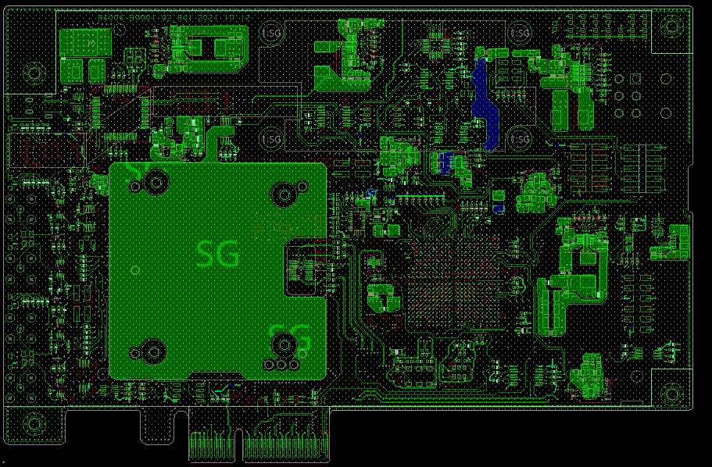
Figure 5 Timing Card Placement

Detailed Design Description

Functional overview

The timing card provides a very accurate synchronous timing source within a datacenter environment. It gets accurate timing information from the Global Navigation Satellite System (GNSS). It also has a miniature atomic clock on board that provides holdover with time error <1us in 24 hours.
A GNSS antenna (u-blox ANN_MB) can be connected to the designated SMA connector so that the GNSS timing receiver (u-blox RCB-F9T) can receive accurate timing information from GNSS. RCB-F9T send the timing information (1PPS) to the FPGA. FPGA performs PTP computations and sends 1PPS and 10MHz timing signals to the designated SMA connectors, which are in turn connected to a Mellanox CX6 NIC through a standard SMA cables. 1PPS and 10MHz timing signals from the NIC are also connected to the FPGA through the designated SMA inputs.
In the event that GNSS signal is lost, the FPGA enters holdover mode. During holdover, Microchip MAC-SA53 miniature atomic clock is used as the timing source. During holdover, MAC-SA53 guarantees a time error <1us in 24 Hours. When GNSS connection is re-established, the FPGA automatically switches the clock source to be the RCB-F9T.

I2C Tree
The FPGA communicates with all the on-board environmental sensors. One PCA9546A I2C bus switch (4 channels) is used to segment the I2C bus and connect to al the sensors.
A separate I2C bus from the FPGA is connected to the board ID EEPROM with built-in EUI64 MAC address and a unique 128-bit serial number. Another EEPROM for FPGA version and other related data is also on the same bus.
The on-board sensor devices are:
- 3x TI LM75B Temperature sensors
- Sensirion SHT31A-DIS humidity sensor
- TDK ICP-10100 Pressure sensor
- Ceva BNO085 vibration sensor
The PCA9546A base address is 0x70. The individual device addresses are shown in the table below.

Main Bus name | PCA9546A Channel | Address | RefDes | Device
PCA9546A_I2C | 0 | 0x48 | U8 | LM75B (exhaust)
PCA9546A_I2C | 0 | 0x49 | U35 | LM75B (near Atomic clock)
PCA9546A_I2C | 0 | 0x4A | U36 | LM75B (inlet)
PCA9546A_I2C | 1 | 0x44/0x45 | U27 | SHT31A-DIS
PCA9546A_I2C | 2 | 0x63 | U28 | ICP-10100
PCA9546A_I2C | 3 | 0x4A | U29 | BNO085
EEPROM_I2C | N/A | 0x50/0x58 | U7 | AT24MAC602 Serial EEPROM with EUI64 address and 128-bit serial number
EEPROM_I2C | N/A | 0x51 | U19 | 24LC64T Serial EEPROM for FPGA version
Table 5 Timing board I2C address

System Reset

There are several ways to accomplish a board reset.
- Power up: The the board is plugged into the server PCIe slot and the server is powered up, a reset is performed afte all the voltages stabilize and the FPGA is configured.
- PERst assertion: When PERST is asserted by the server CPU, the FPGA wil be reconfigured and the subsequently the board will be reset.
- Manual reset using a push button (debug only).

System Monitoring and Control

Environmental sensors
The FPGA periodically polls the temperature sensors at the inlet, exhaust and near the atomic clock, as well as the pressure sensor, humidity sensor and vibration sensor and stores the data in internal registers. The server CPU can access this data through the PCIe interface.
Interrupt lines from the sensors are also directly connected to the FPGA. In case any of the readings goes beyond a preset threshold, the appropriate sensor asserts the interrupt.

Clock Design

Clock Requirements
Besides the high precision miniature Atomic clock, there are three other clock sources in the timing card:
- One 200MHz reference clock for the FPGA
- One 125MHz reference clock for the FPGA
- One 32.768KHz Crystal for the BNO085 vibration sensor.

On board Power Design

On board Power Requirement Analysis
The power consumption of Timing card is show as below

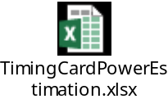

Power Sequence Requirement Analysis

Timing Board Sequence Requirement
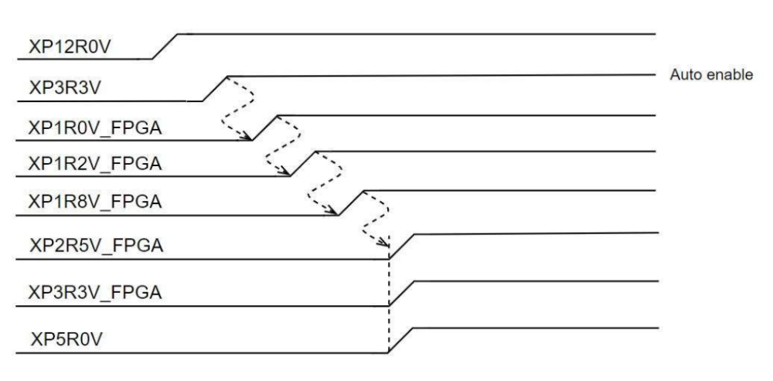
Figure 6 Timing Board power sequence requirement

On Board Power Solution

Power Tree

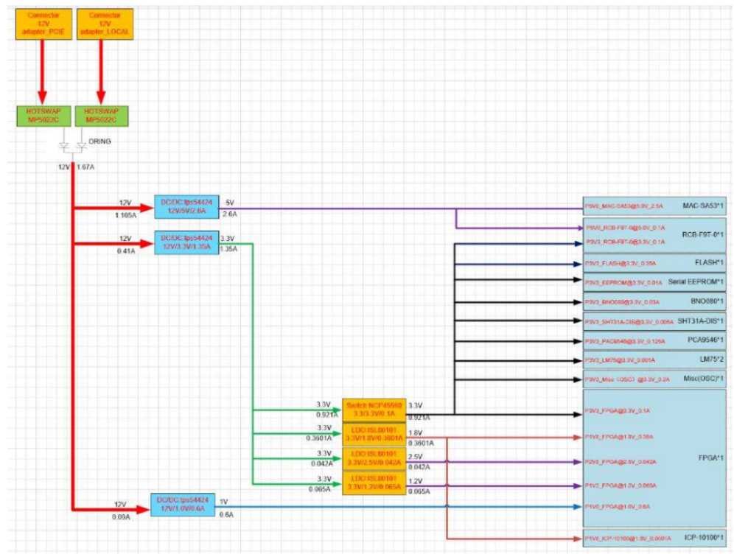
Figure 7 Power Tree

JTAG

The JTAG connector is used for programming the FPGA image flash.

LEDs

Front Panel LEDs

Front panel has one Tri-color LED for each SMA ports (5 total). LED definition is TBD.

LED | Default  Power-On  State | Color | Condition
SMA1 | Off | Blue | TBD
SMA1 | Off | Amber | TBD
SMA1 | Off | Green | TBD
SMA2 | Off | Blue | TBD
SMA2 | Off | Amber | TBD
SMA2 | Off | Green | TBD
SMA3 | Off | Blue | TBD
SMA3 | Off | Amber | TBD
SMA3 | Off | Green | TBD
SMA4 | Off | Blue | TBD
SMA4 | Off | Amber | TBD
SMA4 | Off | Green | TBD
SMA5 | Off | Blue | TBD
SMA5 | Off | Amber | TBD
SMA5 | Off | Green | TBD

Table 6 Front panel LED definition

Hardware Reliability Calculation
- Define Calculation Tool
- Define Calculation Method
- Pre-calculation result

Manufacturing Process
<This section will cover manufacturing related issue>
- Define PWB Technology (e.g. layer structure, stack-up, thickness, material, surface, blind vias)
- Define Assembly Technology (e.g. SMT only, one-sided equipage only, press-fit, Pb-free, etc.)
- Check Restrictions due to Combinations of Assembly Technologies

Board Verification Concept
<This section will cover board validation issue / requirement>

- Define Test Concept (functional, electrical, optical, environmental, EMC)
- Define User Interface for TestSW (e.g. HPVEE, LabView, etc.)
- Create Rough Specification for Design Validation Test Plan (e.g bullet item list)
- Define TestSW Platform (e.g. Utilities, script)
- Create Rough Specification of Test and Diagnostic SW (e.g. commands like high-level drivers or more complex commands for debugging)
- Define Requirements of Measuring Equipment (e.g. instruments, cables, adapters, test boards, shelves, card holders etc.) and order Measuring Equipment if necessary. If necessary, define test boards specification.
- Provide Space for Emulator Heads, Sockets etc. Update design architecture (e.g. placement) if necessary.

Design Analyze
<This section will cover DA function of Celestica >
- Define Simulation Objectives (e.g. analog, digital, behavioural, specific design functions)
- Define Simulation Tools
- The result of simulation, including critical signal, pre-SI.

Preliminary Calculation Cost on the Board
<This section will record preliminary cost calculation based on the draft BOM>
- Calculate Preliminary CBOM for Volume Production (based on major contributors)

Environmenntal
  - Environmental Specifications

